SB Stocks
Paper Trading Simulation Platform
Full Stack Development (MERN) — Project Documentation
Team Members: RAMIGANI LAYA (TEAMLEAD)
ANISETTI NAGA CHAKRA SWAMY
BUSI DHARMA TEJA

Table of Contents
1. Introduction
2. Project Overview
3. Architecture
4. Setup Instructions
5. Folder Structure
6. Running the Application
7. API Documentation
8. Authentication
9. User Interface
10. Testing
11. Screenshots or Demo
12. Known Issues
13. Future Enhancements

1. Introduction

Project Title
SB Stocks — Paper Trading Simulation Platform

Team Members
Ramigani Laya (Team lead)
Anisetti Naga Chakra Swamy
Busi Dharma Teja

2. Project Overview

Purpose
SB Stocks is a full-stack MERN (MongoDB, Express, React, Node.js) application that lets users practice buying and selling US-listed stocks using virtual funds, in a completely risk-free simulated market. Every new account starts with $100,000 in virtual funds, and stock prices move on their own via a server-side simulation, so the experience feels like trading in a live market without any real financial risk or the need for a paid market-data subscription.
The goal of the project is to give students, beginners, and hobbyist traders a safe sandbox to learn how buying, selling, portfolio tracking, and market fluctuations work, before ever risking real money.

Features
- Secure registration & login using JWT authentication and bcrypt password hashing
- Role-based access control — separate "user" and "admin" roles
- Simulated real-time market data — stock prices tick every 10 seconds with a randomised ±2% walk, so charts and quotes move like a live market
- Stock browsing & search across all listed stocks, with a per-stock price history chart
- Paper trading — Buy / Sell modals that debit or credit a virtual wallet instantly
- Portfolio management — live holdings, average buy price, current market value, and profit/loss
- Watchlist — star stocks to track without owning them
- Transaction history — a complete audit trail of every buy/sell order
- Admin panel — manage the stock catalog (create, update, delete listings), and view all users and all transactions across the platform

3. Architecture

Frontend — React
The client is a single-page application built with React 18 and bundled with Vite. Routing is handled by react-router-dom v6, with two route guards:
- ProtectedRoute.jsx — redirects to /login if no authenticated user is present
- AdminRoute.jsx — redirects non-admin users away from /admin routes
Global authentication state (the logged-in user, their JWT, and their virtual fund balance) is managed through a React Context (AuthContext.jsx) and persisted to localStorage so a session survives a page refresh. All HTTP calls go through a shared Axios instance (api/axios.js) that automatically attaches the JWT as a Bearer token to every outgoing request via an Axios request interceptor.
Styling is done with Tailwind CSS utility classes — pages use a light indigo/sky/emerald gradient background with translucent white cards, and Chart.js (via react-chartjs-2) renders the per-stock price history line chart. Toast notifications (react-toastify) provide feedback for actions like login, trade orders, and errors.

Backend — Node.js & Express.js
The server is a REST API built with Express.js. Its responsibilities are organised into three layers:
- Routes (routes/) — define the URL paths and HTTP methods, and wire up middleware (auth, admin checks) per endpoint
- Controllers (controllers/) — contain the business logic for each resource (users, stocks, orders, portfolio, watchlist, transactions)
- Middlewares (middlewares/authMiddleware.js) — protect verifies the JWT and attaches the authenticated user to the request; adminOnly restricts a route to admin-role users
A background job (a setInterval in index.js, firing every 10 seconds) calls simulateMarketTick() in stockController.js, which nudges every active stock's price by a random ±2% and appends the new price to that stock's history array — this is what powers the "live" market feeling without needing a real market-data API key.

Database — MongoDB
Data is stored in MongoDB and accessed through Mongoose schemas. The five core collections are:

User
- name, email (unique), password (bcrypt-hashed), contact
- role — "user" or "admin" (default: "user")
- funds — virtual wallet balance (default: 100000)

Stock
- symbol (unique), name, sector, exchange
- price, previousClose, dayHigh, dayLow, volume
- history — an embedded array of { date, price } points used to draw the chart
- isActive — soft flag so a stock can be delisted without deleting past transaction records

Portfolio
- user (ref → User), name
- holdings — embedded array of { stock (ref → Stock), symbol, quantity, avgBuyPrice }

Transaction
- user (ref → User), stock (ref → Stock), symbol
- transactionType — "BUY" or "SELL"
- quantity, price, total, paymentMode, orderType, orderStatus

Watchlist
- user (ref → User, unique — one watchlist per user)
- stocks — array of Stock references
Relationships are modelled with Mongoose ObjectId references and populate() calls (for example, a portfolio's holdings reference the Stock collection so the current price can be joined in at read time), while frequently-accessed denormalised fields like symbol are also stored directly on Portfolio and Transaction documents to avoid an extra lookup on every read.

4. Setup Instructions

Prerequisites
- Node.js v16 or later
- npm (bundled with Node.js)
- A MongoDB database — either a local MongoDB instance, or a free MongoDB Atlas cluster

Installation

1. Clone the repository
git clone <repository-url>
cd sb-stocks

2. Backend setup
cd server
npm install
cp .env.example .env # then edit MONGO_URI / JWT_SECRET as needed
Edit the newly-created server/.env file:
MONGO_URI=mongodb://127.0.0.1:27017/sbstocks
JWT_SECRET=replace_this_with_a_long_random_secret
PORT=5000
CLIENT_URL=http://localhost:5173
If using MongoDB Atlas instead of a local database, replace MONGO_URI with your Atlas connection string (found under Database → Connect → Drivers), and make sure your current IP address is added under Atlas's Network Access settings.

3. Seed the database (optional but recommended)
npm run seed
This creates an admin account (admin@sbstocks.com / Admin@123) and a starter set of 12 well-known US stocks (AAPL, MSFT, GOOGL, AMZN, TSLA, META, NVDA, NFLX, JPM, V, DIS, KO).

4. Frontend setup
cd ../client
npm install
cp .env.example .env # VITE_API_URL should point at your backend
VITE_API_URL=http://localhost:5000/api

5. Folder Structure

Client (React frontend)
client/
├── src/
│ ├── api/
│ │ └── axios.js # shared Axios instance, attaches JWT to requests
│ ├── components/
│ │ ├── Navbar.jsx
│ │ ├── StockCard.jsx
│ │ ├── StockChart.jsx
│ │ ├── TradeModal.jsx
│ │ ├── Loader.jsx
│ │ ├── ProtectedRoute.jsx
│ │ └── AdminRoute.jsx
│ ├── context/
│ │ └── AuthContext.jsx # JWT session state (login/register/logout)
│ ├── pages/
│ │ ├── Landing.jsx
│ │ ├── Login.jsx
│ │ ├── Register.jsx
│ │ ├── Dashboard.jsx
│ │ ├── Stocks.jsx
│ │ ├── StockDetail.jsx
│ │ ├── Portfolio.jsx
│ │ ├── Watchlist.jsx
│ │ ├── Transactions.jsx
│ │ └── Admin/
│ │ ├── AdminDashboard.jsx
│ │ └── ManageStocks.jsx
│ ├── App.jsx # route definitions
│ └── main.jsx # React entry point
├── index.html
├── tailwind.config.js
├── vite.config.js
└── package.json

Server (Node.js / Express backend)
server/
├── config/
│ └── db.js # MongoDB connection (Mongoose)
├── controllers/
│ ├── userController.js # register, login, profile, deposit/withdraw
│ ├── stockController.js # CRUD + market tick simulation
│ ├── orderController.js # buy / sell logic
│ ├── portfolioController.js
│ ├── watchlistController.js
│ └── transactionController.js
├── middlewares/
│ └── authMiddleware.js # protect (JWT check), adminOnly
├── models/
│ ├── userModel.js
│ ├── stockModel.js
│ ├── portfolioModel.js
│ ├── watchlistModel.js
│ └── transactionModel.js
├── routes/
│ ├── userRoute.js
│ ├── stockRoute.js
│ ├── orderRoute.js
│ ├── portfolioRoute.js
│ ├── watchlistRoute.js
│ └── transactionRoute.js
├── seed.js # seeds admin user + starter stock listings
├── index.js # app entry point, mounts routes + market simulator
└── package.json

6. Running the Application
Both the backend and frontend need to be running at the same time, in two separate terminals.

Backend
cd server
npm run dev # starts the API on http://localhost:5000 with auto-reload (nodemon)
# or: npm start # runs without auto-reload

Frontend
cd client
npm run dev # starts the app on http://localhost:5173
Once both are running, open http://localhost:5173 in your browser. Register a new account (which starts with $100,000 in virtual funds) or log in with the seeded admin credentials (admin@sbstocks.com / Admin@123) to access the admin panel at /admin.

7. API Documentation
All endpoints are prefixed with /api. Endpoints marked "User" require a valid JWT (sent as an Authorization: Bearer <token> header); endpoints marked "Admin" additionally require the authenticated user's role to be "admin". A basic health check is also available at GET /api/health.

User & Auth Routes
Method | Endpoint | Auth | Description
POST | /api/users/register | Public | Register a new user. Body: name, email, password, contact. Returns user + JWT.
POST | /api/users/login | Public | Authenticate a user. Body: email, password. Returns user + JWT.
GET | /api/users/profile | User | Returns the logged-in user's profile.
PUT | /api/users/profile | User | Update name / contact / password.
POST | /api/users/deposit | User | Deposit virtual funds. Body: amount.
POST | /api/users/withdraw | User | Withdraw virtual funds. Body: amount.
GET | /api/users | Admin | List all registered users.

Stock Routes

Method | Endpoint | Auth | Description
GET | /api/stocks | Public | List active stocks. Optional query params: search, sector.
GET | /api/stocks/:symbol | Public | Get one stock by symbol, including price history.
POST | /api/stocks | Admin | Create a new stock listing. Body: symbol, name, sector, exchange, price.
PUT | /api/stocks/:id | Admin | Update a stock listing's fields (price update also appends to history).
DELETE | /api/stocks/:id | Admin | Delete a stock listing.

Order Routes (Buy / Sell)

Method | Endpoint | Auth | Description
POST | /api/orders/buy | User | Buy shares. Body: symbol, quantity. Debits virtual funds, updates holdings.
POST | /api/orders/sell | User | Sell shares. Body: symbol, quantity. Credits virtual funds, updates holdings.

Portfolio Routes

Method | Endpoint | Auth | Description
GET | /api/portfolio | User | Get the logged-in user's holdings with live valuation and profit/loss.

Watchlist Routes

Method | Endpoint | Auth | Description
GET | /api/watchlist | User | Get the logged-in user's watchlist.
POST | /api/watchlist/:symbol | User | Add a stock to the watchlist.
DELETE | /api/watchlist/:symbol | User | Remove a stock from the watchlist.

Transaction Routes

Method | Endpoint | Auth | Description
GET | /api/transactions | User | Get the logged-in user's transaction history.
GET | /api/transactions/all | Admin | Get every transaction across all users.

Example Request / Response
POST /api/users/login
Request body:
{ "email": "admin@sbstocks.com", "password": "Admin@123" }
Response 200:
{
"_id": "665f1c2e8b1a2c0012ab34cd",
"name": "SB Stocks Admin",
"email": "admin@sbstocks.com",
"role": "admin",
"funds": 1000000,
"token": "eyJhbGciOiJIUzI1NiIsInR5cCI6IkpXVCJ9..."
}

8. Authentication
Authentication is implemented with JSON Web Tokens (JWT) rather than server-side sessions, keeping the API stateless.

Registration & Login
- Passwords are hashed with bcryptjs (10 salt rounds) before being stored — plaintext passwords are never persisted.
- On successful registration or login, the server signs a JWT containing the user's id and role, valid for 7 days, using the JWT_SECRET environment variable.
- The token is returned to the client alongside the user's profile (name, email, role, funds).

Session Persistence (Client)
- The client stores the full login response (including the token) in localStorage under the key sbStocksUser.
- An Axios request interceptor (api/axios.js) reads this token on every outgoing request and attaches it as an Authorization: Bearer <token> header automatically.

Route Protection (Server)
- The protect middleware verifies the JWT signature and expiry, loads the corresponding user from MongoDB (excluding the password field), and attaches it to req.user for downstream controllers to use.
- The adminOnly middleware runs after protect and rejects the request with 403 Forbidden unless req.user.role === "admin".

Route Protection (Client)
- ProtectedRoute.jsx redirects unauthenticated users to /login before rendering any page that requires a logged-in user.
- AdminRoute.jsx additionally redirects non-admin users to /dashboard, so only the seeded/admin-role account can reach /admin and /admin/stocks.

9. User Interface
The interface uses a consistent light theme across every page — a soft indigo-to-sky-to-emerald gradient background, translucent white cards, and a dark indigo navigation bar. Stock-market photography is used in page headers to reinforce the trading theme.

Public Pages
- Landing — marketing page introducing the platform, its four key features, and calls to action to register or log in.
- Login / Register — split-panel forms with a stock-photo side panel and a light, validated form on the other.

Authenticated Pages
- Dashboard — welcome banner, available funds / portfolio value / unrealized P&L stat cards, and a "Market Movers" grid of stocks.
- Stocks — searchable grid of all listed stocks with live price and percentage change.
- Stock Detail — price chart, day high/low/volume stats, and Buy / Sell / Watchlist actions for a single stock.
- Portfolio — invested value, current value, and total P&L stat cards, plus a holdings table.
- Watchlist — grid of starred stocks the user is tracking.
- Transaction History — a chronological table of every buy/sell order.

Admin Pages
- Admin Dashboard — platform-wide stats: registered users, listed stocks, total transactions.
- Manage Stock Listings — a form to add/update stock listings, plus a table to edit or delete existing ones.

Screenshots
[Insert screenshots or a short screen-recording/GIF of each page listed above here before submitting — Dashboard, Stocks, Stock Detail with a Buy/Sell in progress, Portfolio, Watchlist, Transaction History, and the Admin panel are the most useful to include.]

10. Testing
The project does not currently include an automated test suite. Testing was carried out manually during development:
- API endpoints were exercised with a REST client (e.g. Postman/Thunder Client) to verify status codes, validation errors (missing fields, insufficient funds, insufficient shares), and JWT-protected/admin-only access control.
- Frontend flows (register → login → buy → sell → portfolio update → watchlist toggle → transaction history) were manually walked through in the browser across each role (regular user and admin).
- MongoDB documents were inspected directly (via MongoDB Atlas's Data Explorer / Compass) after each action to confirm holdings, funds, and transaction records updated correctly.
[Recommended future addition: automated tests with Jest + Supertest for the API layer, and React Testing Library for key frontend components/pages — see Future Enhancements.]

11. Output screens
The following screenshots were captured from the running application (client on http://localhost:5173) and walk through the full user journey — from the public landing page, through registration and login, to the authenticated dashboard, trading, and admin tools.

Landing Page
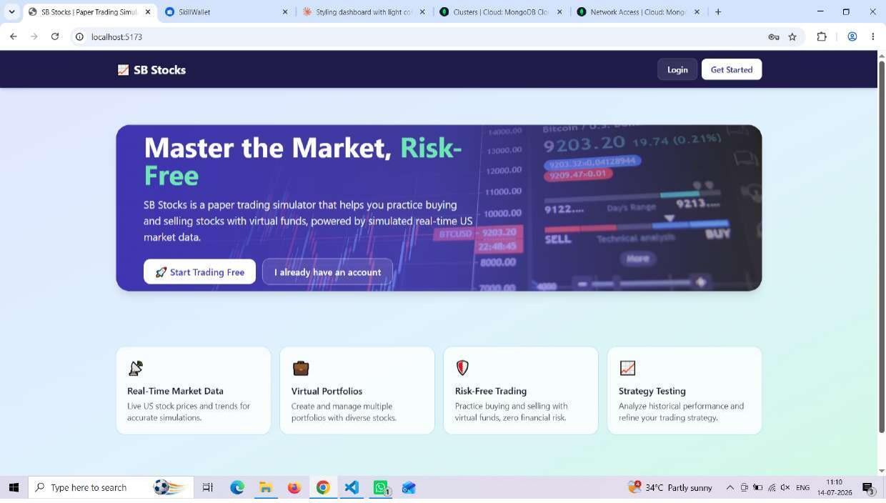
Public landing page introducing SB Stocks, its key features, and calls to action to register or log in.

Register
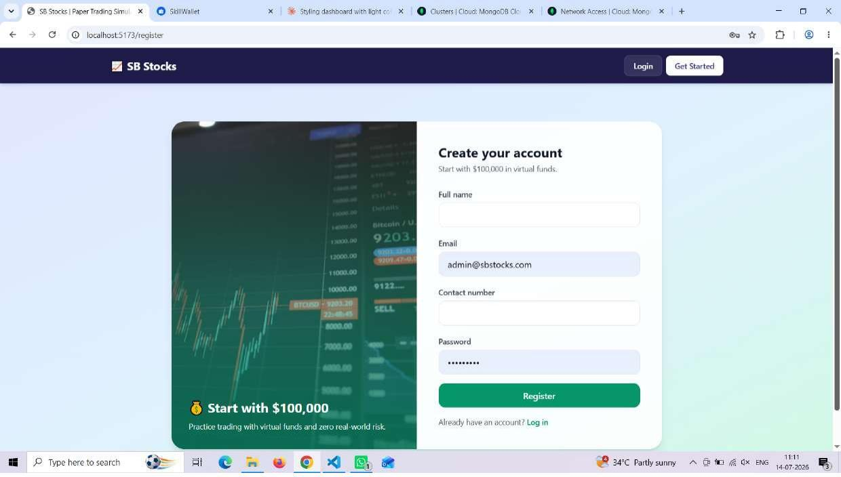
Account registration form — every new account starts with $100,000 in virtual funds.

Login
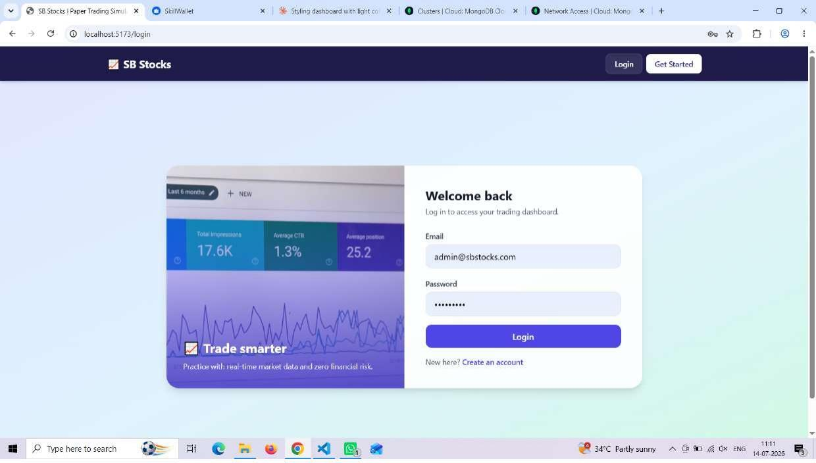
Login form for returning users.

Dashboard
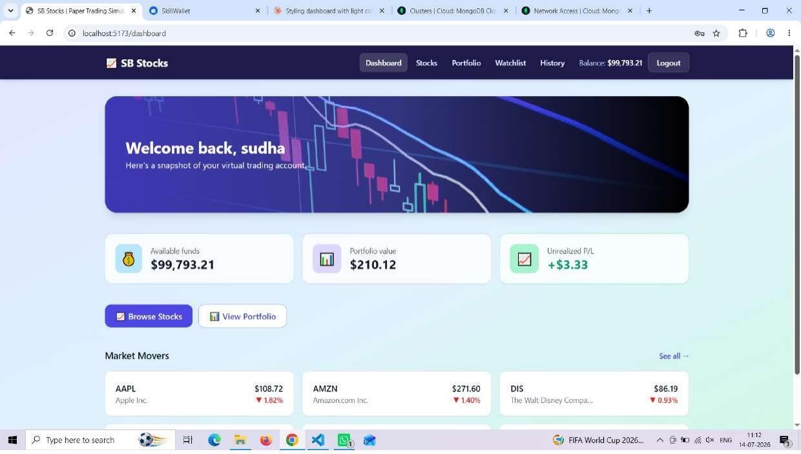
Authenticated dashboard showing available funds, portfolio value, unrealized P/L, and Market Movers.

Browse Stocks
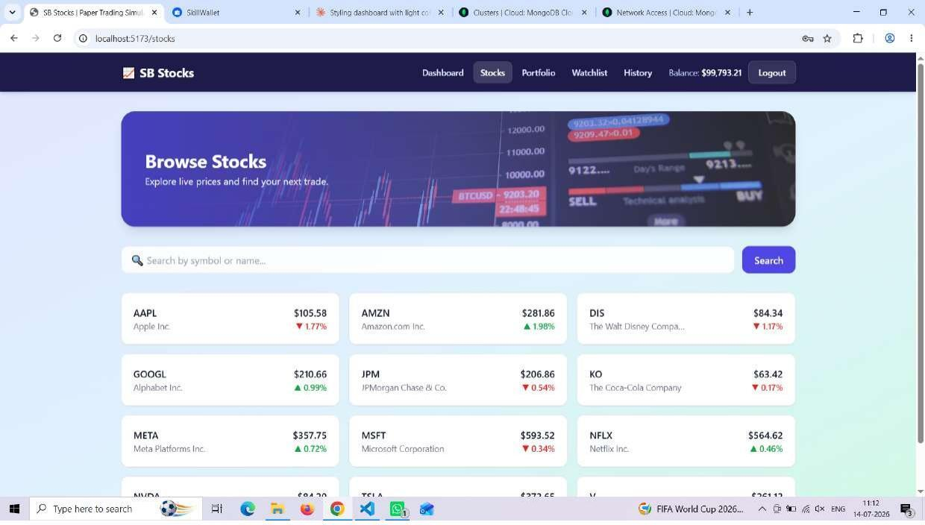
Searchable grid of all listed stocks with live prices and percentage change.

Portfolio
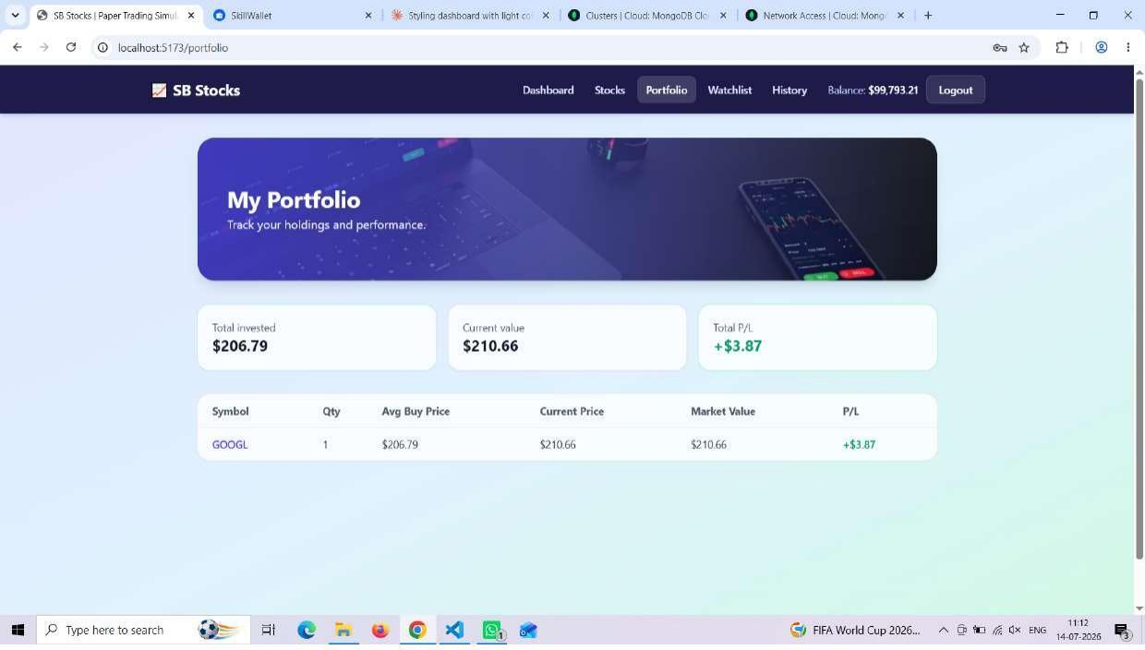
Portfolio page showing total invested, current value, total P/L, and a holdings table.

Watchlist
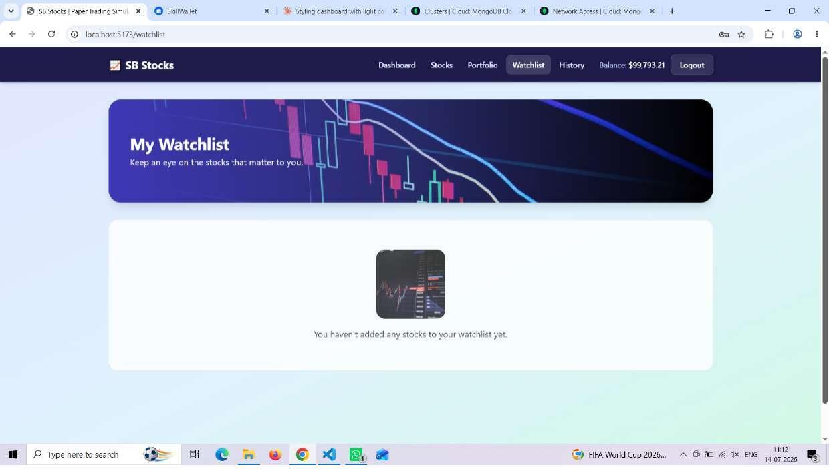
Watchlist page (shown here in its empty state) for stocks the user wants to track without owning.

Transaction History
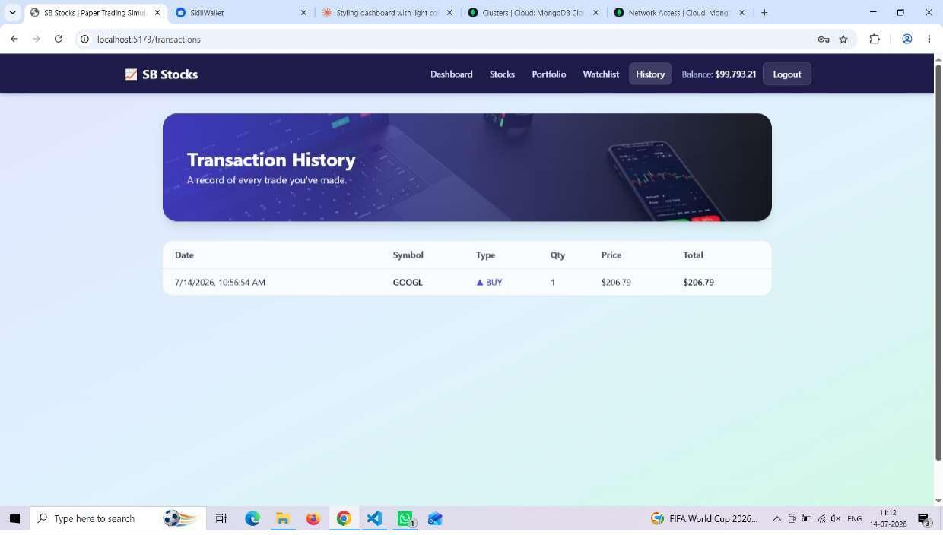
Transaction history showing a completed BUY order for GOOGL.

Admin Dashboard
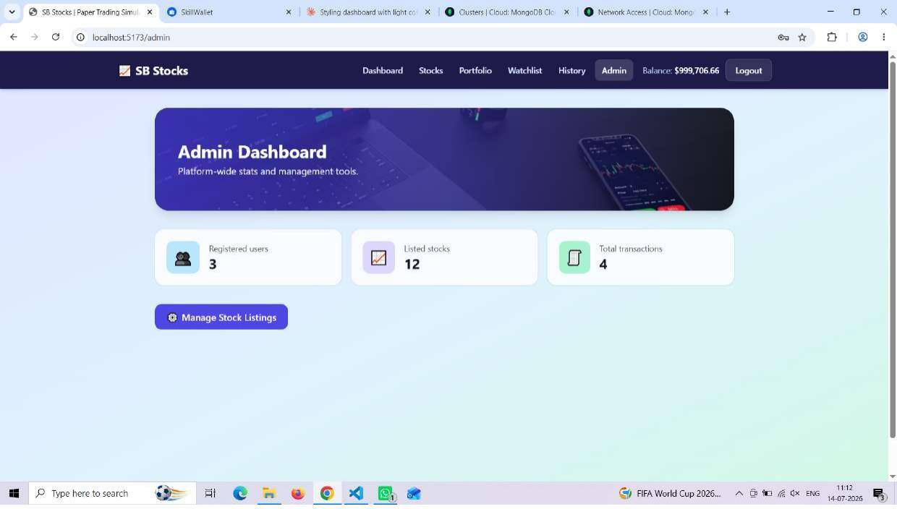
Admin dashboard with platform-wide stats — registered users, listed stocks, and total transactions.

Manage Stock Listings (Admin)
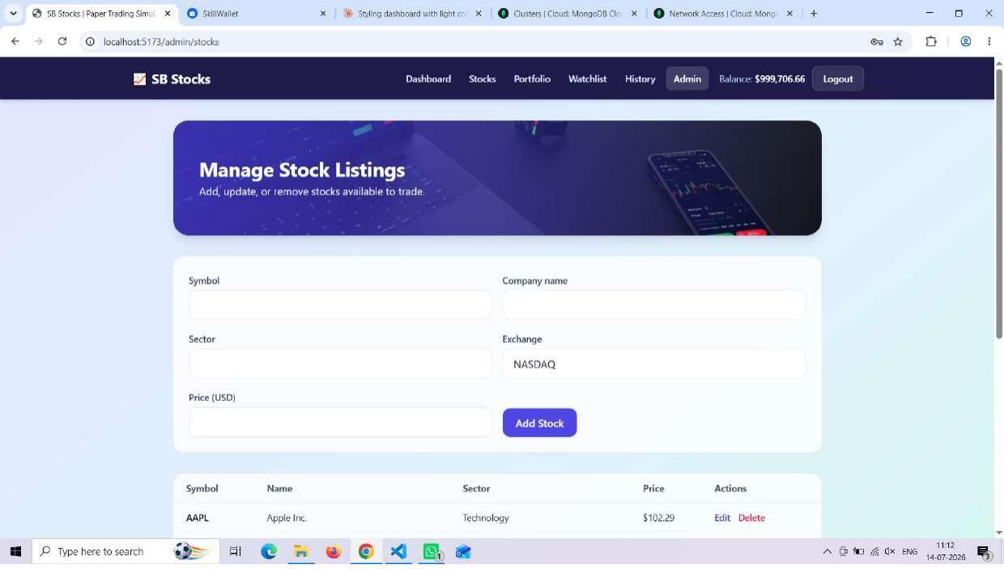
Admin tool to add, edit, or delete stock listings available to trade.

12. Known Issues
- Market data is simulated (a random ±2% walk every 10 seconds) rather than sourced from a real market-data provider, so prices do not reflect actual market conditions.
- The price simulator runs via setInterval in the same Node process as the API — if the server restarts, the interval simply restarts too, and if multiple server instances are ever run behind a load balancer, prices would tick multiple times per interval unless the job is moved to a dedicated scheduler.
- There is no pagination on the stock list, transaction history, or admin user list — these will slow down as data grows.
- MongoDB Atlas's IP Access List must include the developer's current IP address, or all database connections will be rejected — this is a common setup snag (see Setup Instructions).
- There is no password-reset / forgot-password flow — a user who forgets their password currently has no self-service recovery option.
- Deposit/withdraw endpoints exist on the backend but are not yet wired up to any UI page.

13. Future Enhancements
- Integrate a real market-data API (e.g. Alpha Vantage, Finnhub, or IEX Cloud) in place of simulateMarketTick for genuinely live prices.
- Add limit and stop orders in addition to the current market-only order type.
- Add pagination and infinite scroll to the stock list, transaction history, and admin tables.
- Build a UI for the existing deposit/withdraw endpoints so users can manage their virtual wallet balance.
- Add password-reset via email (e.g. using a one-time token flow).
- Add automated testing: Jest + Supertest for API routes, React Testing Library for components.
- Add leaderboards / portfolio performance rankings across users for a gamified experience.
- Add push/email notifications for significant price moves on watchlisted stocks.
- Deploy to production (e.g. client on Vercel/Netlify, API on Render/Railway, database on MongoDB Atlas) with CI/CD.

